**COVER PAGE**



EEC 521/CIS 534: Software Engineering

Professor: Dr. Yongjian Fu

|  |  |  |
| --- | --- | --- |
| **Team Members** | | |
| Team Member 1 | LIKITH REKAPALLI | CSU ID: 2845684 |
| Team Member 2 | KRISHNA SAI SALLA | CSU ID: 2887720 |

**Hospital Management System (HMS) - User Manual**

**Introduction**

The Hospital Management System (HMS) is designed to streamline operations in healthcare institutions, offering features for medical record management, prescription handling, laboratory report management, and administrative functions. This manual provides step-by-step guidance on using the system effectively for different user roles: administrators, doctors and nurses.

**Table of Contents**

1. Getting Started
2. User Roles and Permissions
3. Features and Functions
   * Login and Access
   * Patient registration
   * Staff registration
   * Patient invoice
   * Room allocation
   * Admitted patient information
4. Troubleshooting

**1. Getting Started**

**System Requirements**

* **Browser**: Latest versions of Google Chrome, Mozilla Firefox, or Microsoft Edge.
* **Device**: Desktop, laptop, or tablet with internet access.
* **Credentials**: Username and password provided by the administrator.

**Logging In**

1. Open a web browser and navigate to the HMS login page.
2. Enter your **username** and **password**.
3. Click **Login**.

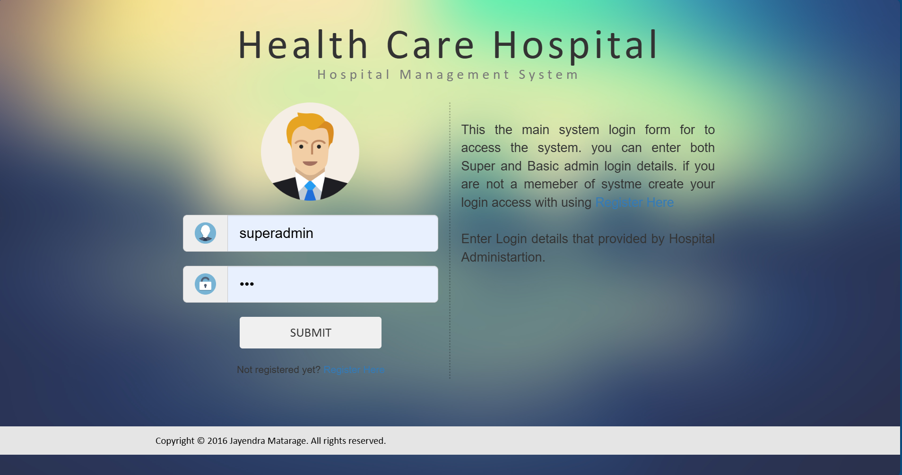

**2. User Roles and Permissions**

**Administrators**

* Manage user accounts, roles, and permissions.
* Monitor system activities.
* Configure system settings.

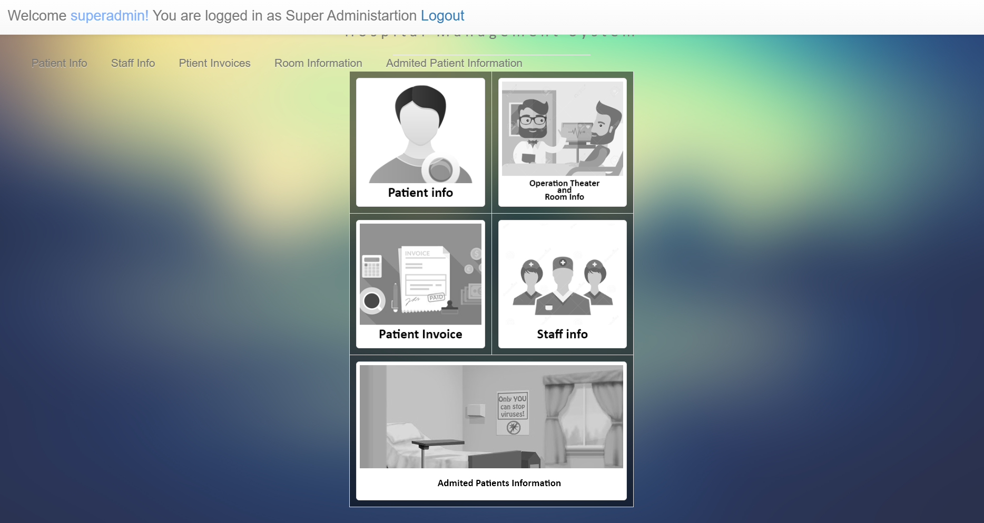

**Doctors and staff**

* Access and update patient medical records.
* Allocate rooms to the patients

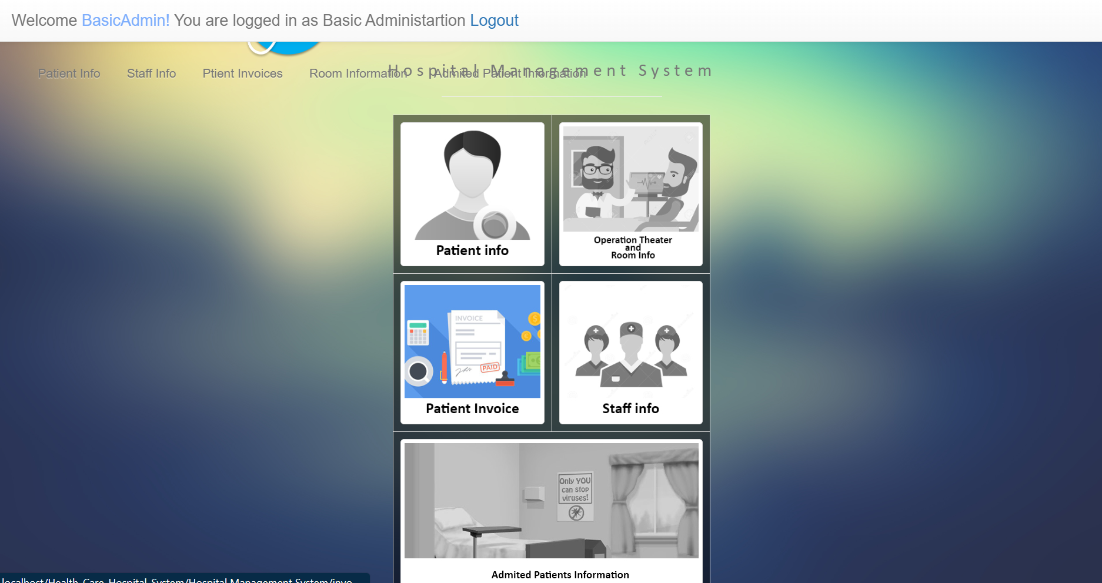

**3. Features and Functions**

**Login and Access**

* Use secure credentials to access the system.
* Logout after each session to maintain security.

**Patient information**

1. Navigate to the **Patients** tab.
2. To add a new patient, click **New Patient** and fill in the required details.
3. View existing patient records by searching their name or ID in the search bar.
4. Update patient details as needed by selecting the **Edit** option.

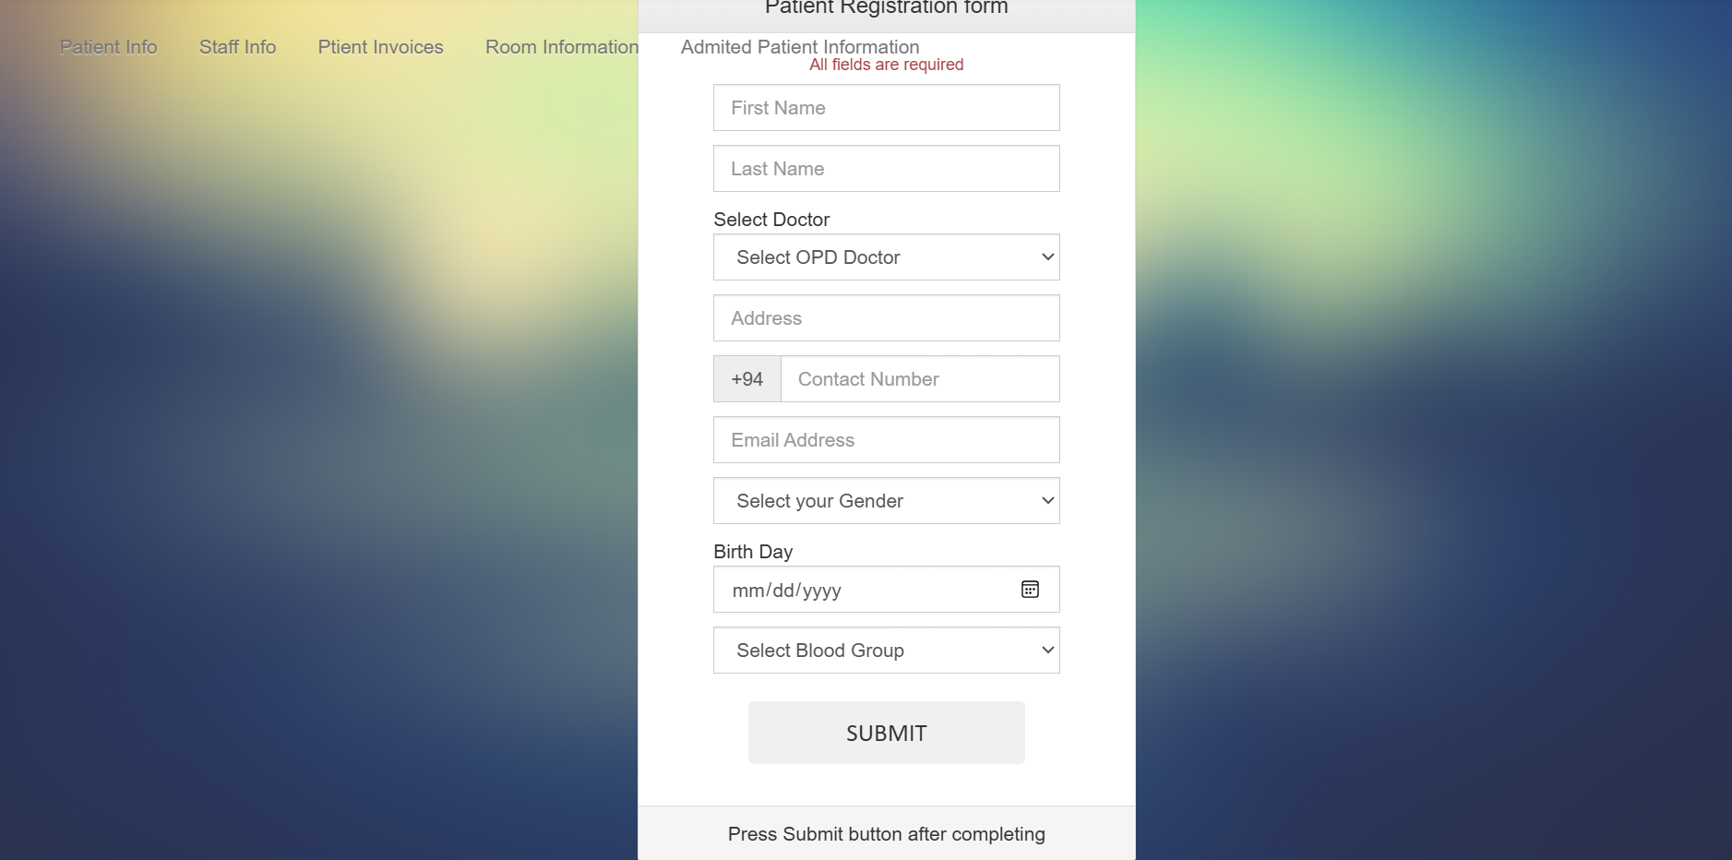

**Staff information**

1. Navigate to the **staff** tab.
2. To add a new member of staff, click **New staff** and fill in the required details.
3. View existing staff records by searching their name or ID in the search bar.
4. Update staff details as needed by selecting the **Edit** option.

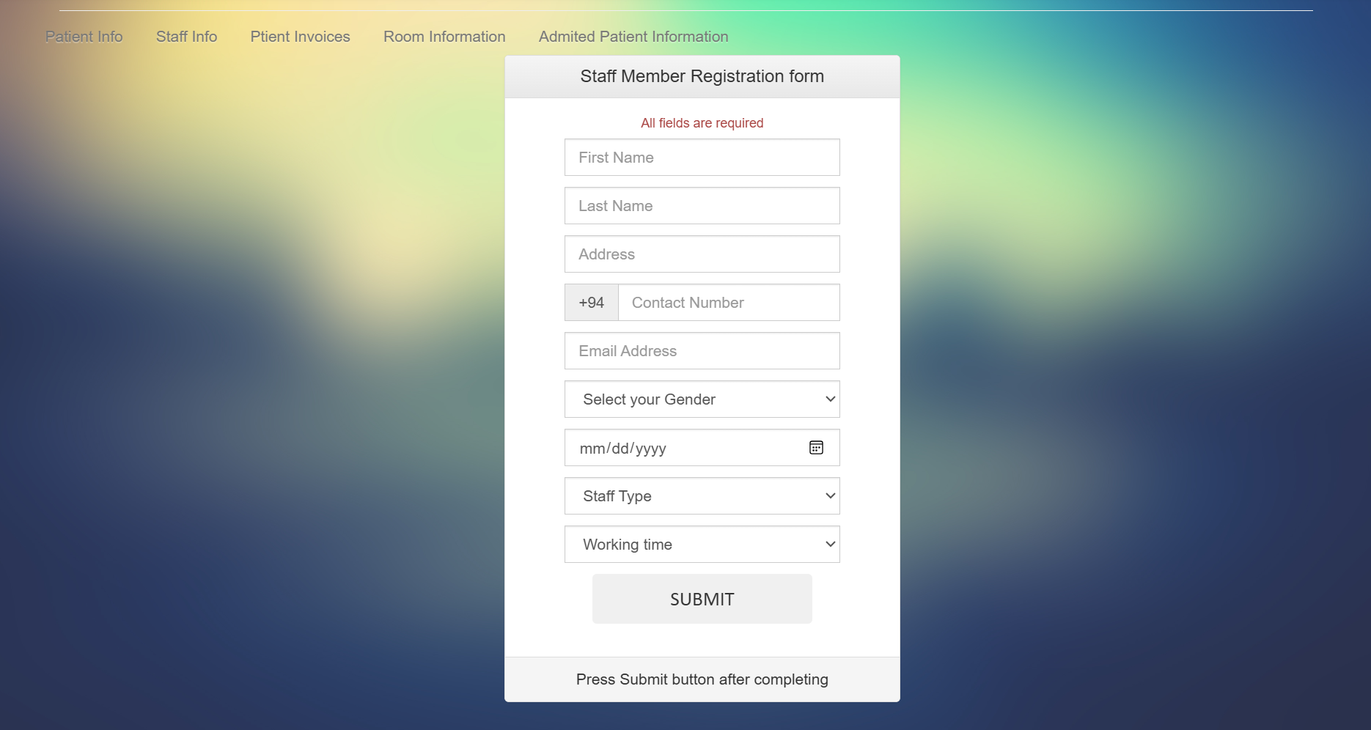

**Patient invoices**

1. Navigate to the **patient invoices** tab.
2. In patient’s invoices tab we can view patients opd invoices and admitted patients invoices

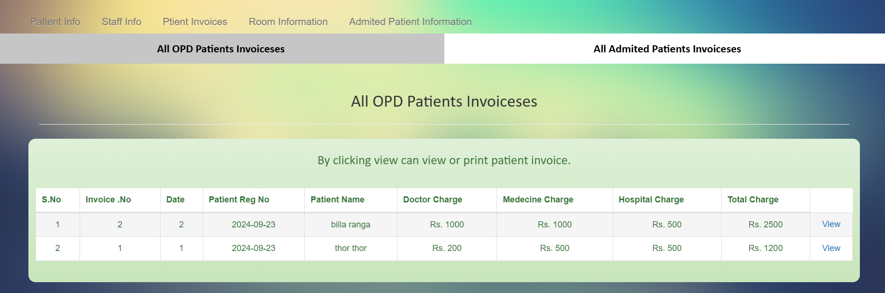

1. To generate a new invoice, navigate to patients info tab and then to patients information tab.
2. Then the admin or staff can generate patients OPD

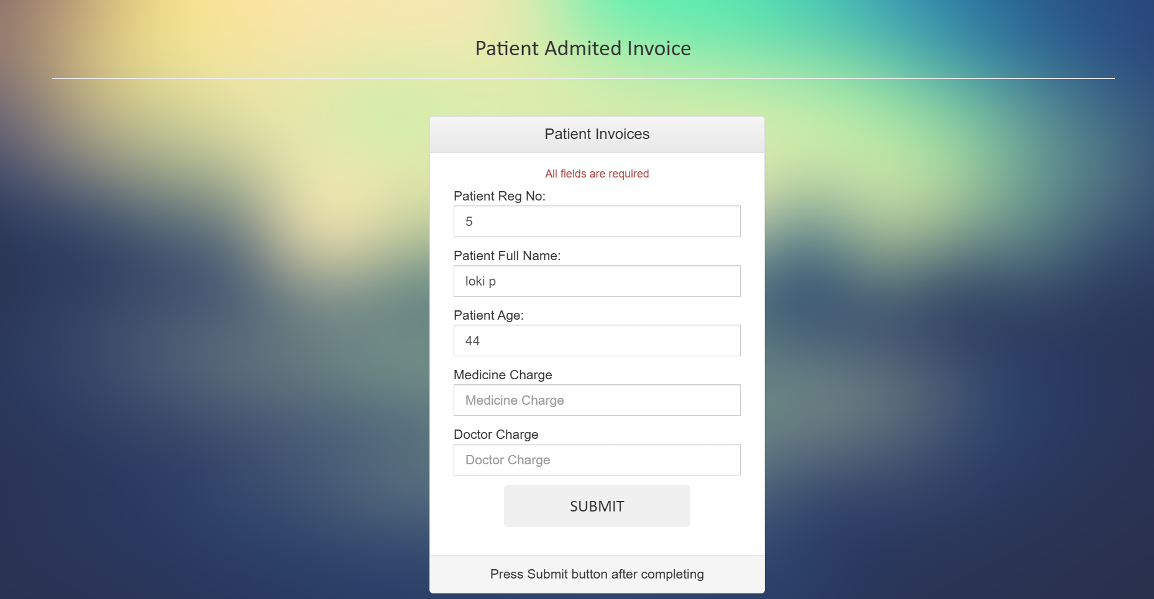

**Room allocation**

We can view the room allocation in this tab.

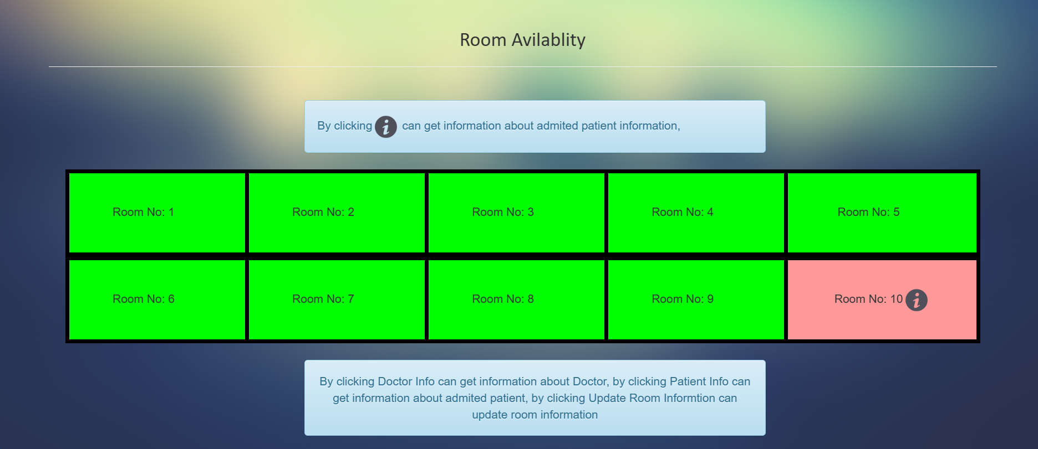

To admit patient in the hospital, navigate to patients info tab

Then navigate to patient’s information tab

Then the staff or admin can admit patient to the hospital

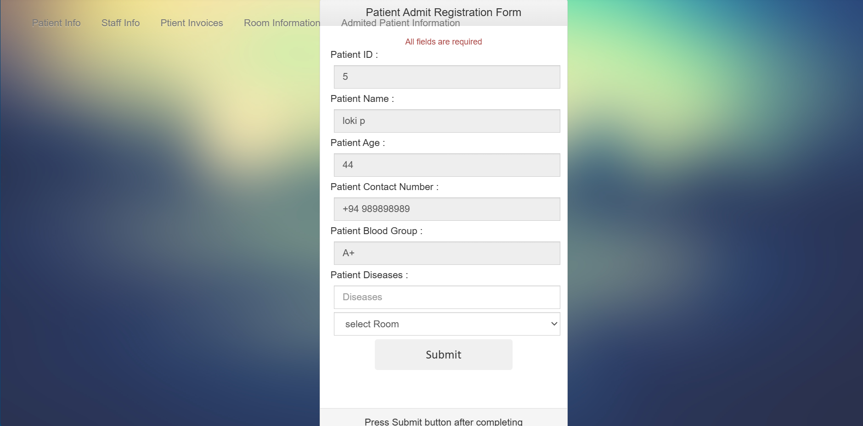

**All admitted patients’ information**

We can view admitted patient information in this tab.

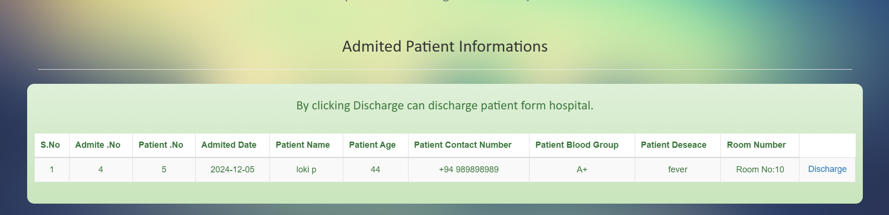

**Discharging patient from the hospital**

Staff or admin can discharge the admitted patient from the hospital by clicking from on the discharge button

Then it will ask to fill in the form based on the days the patient admitted in the hospital and treatment taken the system will automatically generate an invoice.

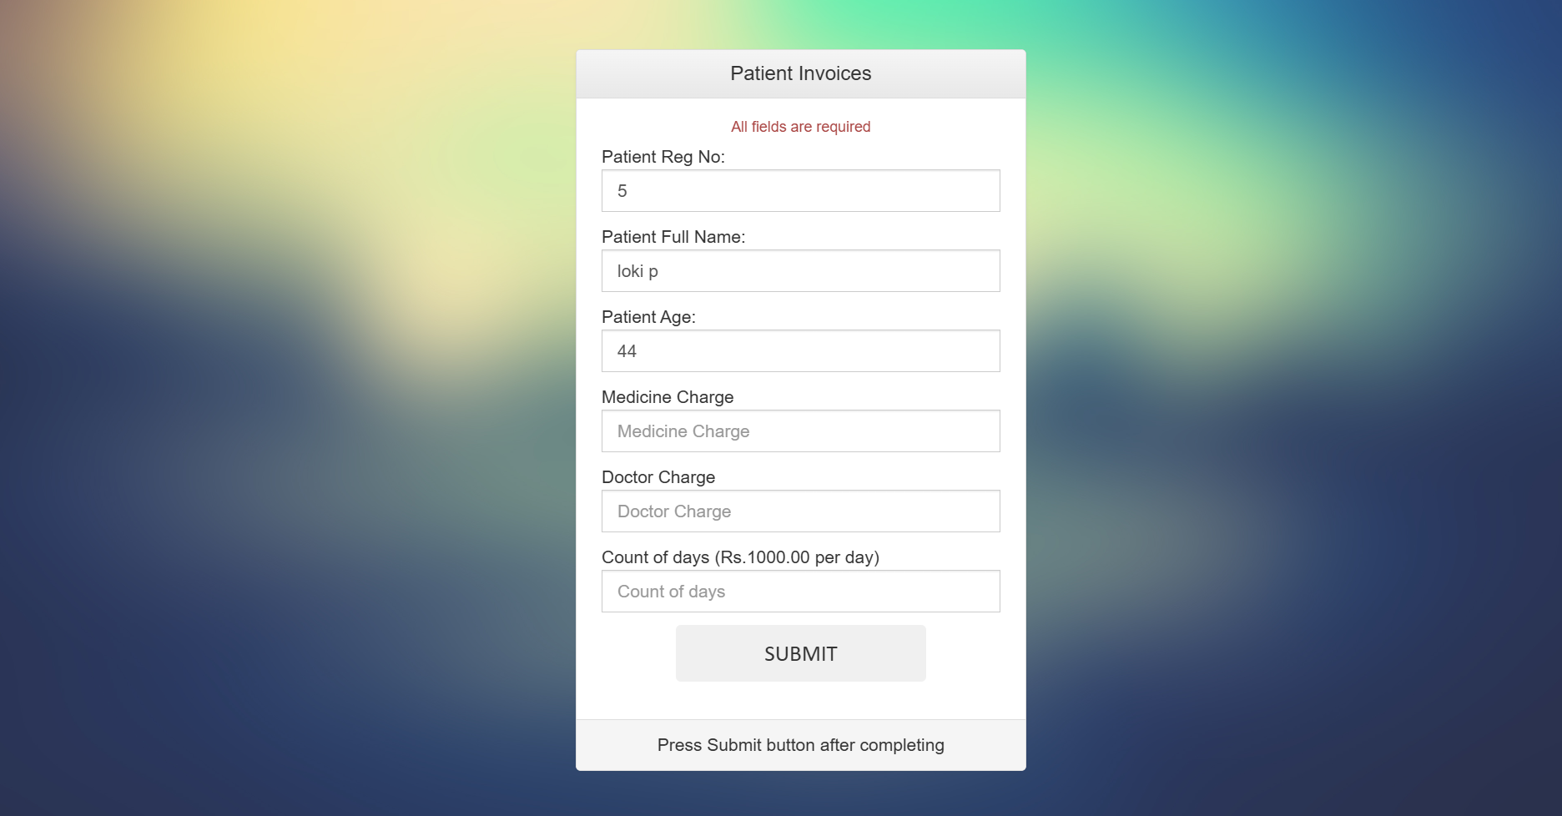

Note – the difference between staff and administration is that the staff cannot edit the information of patient or staff and administrator can do.

**5. Troubleshooting**

**Login Issues**

* Ensure you’re entering the correct username and password.
* Reset your password using the "Forgot Password" link if necessary.

**Data Not Loading**

* Check your internet connection.
* Clear your browser cache and refresh the page.

**Unauthorized Access**

* Verify your role permissions.
* Contact the administrator for assistance.